Layered Network Defense for Luna Bags: TLS, Firewall, and Intrusion Detection
Anurag Karmakar, Asim Pathak
Date: May 3, 2025

Executive Summary
Luna Bags is a small but growing eco-friendly fashion brand. Since the company started building its online presence, its digital systems have become essential to how it runs everything from marketing to finance and customer support depends on them. With around 20 employees working both from the New York office and remotely, protecting these systems is now more important than ever. That’s why Louisa, the IT director, brought me in to lead this project and help strengthen the company’s network security.
To address this, I built a three-layer defense strategy. The first step was enabling HTTPS on the company’s website to make sure any data sent between users and the site is encrypted. Next, I created firewall rules on the router to control which types of traffic are allowed to pass through the network. This limits outside access and helps protect sensitive areas. The final step was setting up Snort, a network monitoring tool that alerts us when something suspicious happens.
All these defenses work together to improve the company’s overall security. HTTPS protects customers and internal data from being intercepted. The firewall reduces the risk of someone reaching parts of the network they shouldn’t. Snort provides an extra layer by alerting us when something doesn’t look right. To make sure everything was working, I simulated attacks like trying to access hidden files, scanning ports, and injecting commands. Snort detected them, and the firewall blocked traffic where it was supposed to.
Of course, there’s still room to grow. Right now, the HTTPS setup uses a self signed certificate, which most browsers don’t fully trust. Also, Snort works best when it’s regularly updated. But overall, the system we put in place gives Luna Bags a strong base to build on as the company continues to grow.

Technical Solution
Now, to get started, we go through the network topology.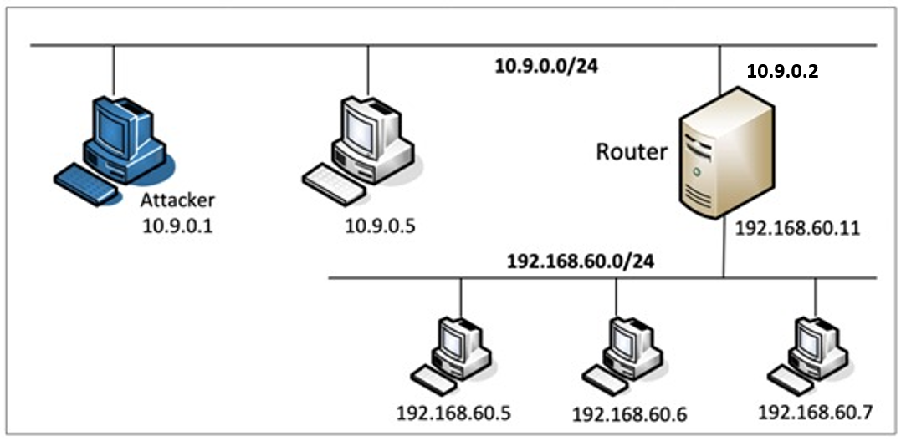

The network infrastructure for Luna Bags is segmented into two zones:
- DMZ (10.9.0.0/24): Hosts public-facing services, including the Apache web server (10.9.0.5) and the attacker machine (10.9.0.1).
- Internal Network (192.168.60.0/24): Contains employee systems and sensitive services (192.168.60.5, 192.168.60.6, 192.168.60.7).
- Router (10.9.0.11 / 192.168.60.11): Functions as a gateway between both networks and serves as the enforcement point for firewall rules and IDS monitoring.
This segmentation ensures that internal systems are not directly exposed to the internet. All incoming and outgoing traffic between the two networks passes through the router, allowing centralized control and inspection.
We began by deploying a simple web server in the DMZ using the Apache2 service. Then we worked to secure the website so that visitors would connect over a reliable HTTPS connection rather than plain HTTP. This was possible by generating a security certificate with OpenSSL, configuring Apache to utilize it, and restarting the server. After making these modifications, we checked the configuration with the command-line tool 'curl' to ensure that the connection was encrypted.
Next, we focused on the router. We cleared it’s existing firewall settings and added new ones to only allow specific kinds of traffic. For example, we let web traffic through to the server but blocked any attempts to reach the internal network from the outside. We also added a rule that slows down repeated pings, which can help prevent one type of attack known as a ping flood.
Finally, we added monitoring to the network by installing a tool called Snort on the router. We wrote simple rules that tell Snort what kind of activity to look out for, like someone trying to open a hidden file on the website or use special commands in the website address. To check if it worked, we acted like attackers and tried out these actions ourselves using testing tools. Snort successfully detected what we were doing and gave us alerts in real time.
Evidence
To confirm that each part of the security setup worked as intended, I ran tests and collected supporting evidence for HTTPS, the firewall, and the intrusion detection system.
For HTTPS, I used the curl -k https://10.9.0.5 command from the attacker machine to connect securely to the Apache server. The response confirmed that the TLS certificate was active and the connection was encrypted. Although the certificate was self-signed and caused a browser warning, the encryption itself worked as expected, ensuring that data between the user and the server was not sent in plain text.
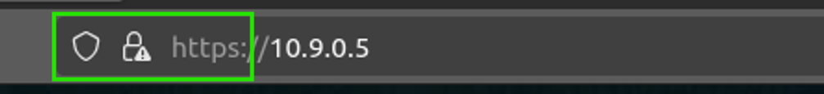
For the firewall, I used the iptables -L -v command on the router to list the active rules and monitor how traffic was being handled. I verified that HTTP and HTTPS traffic to the web server was allowed, while any attempt to access internal IP addresses from the DMZ or external attacker machine was blocked. The byte and packet counters on each rule provided clear confirmation that traffic was matching the expected rules. I also tested a ping flood from the attacker machine and saw that the rate-limiting rule triggered, reducing the volume of ICMP traffic allowed through.
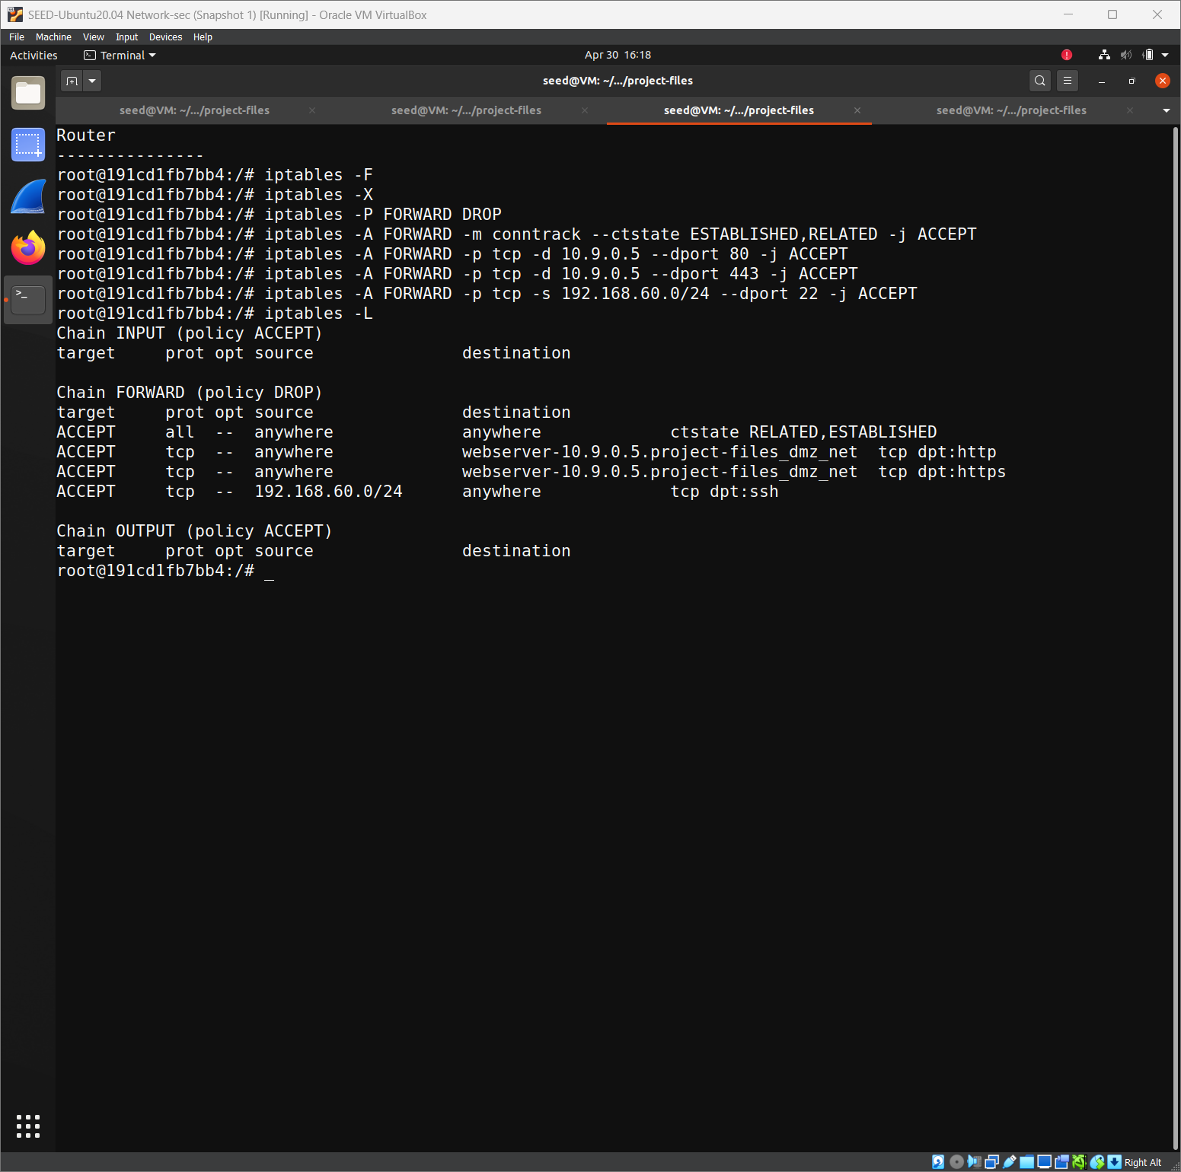
For the intrusion detection system, I tested four different simulated attacks. First, I used curl to access a hidden file path (/.) and to simulate a command injection attempt by adding a suspicious cmd= parameter in the URL. Second, I tried to access a fake admin page (/admin) to simulate unauthorized access. Finally, I ran a stealth scan using nmap -sS from the attacker machine.
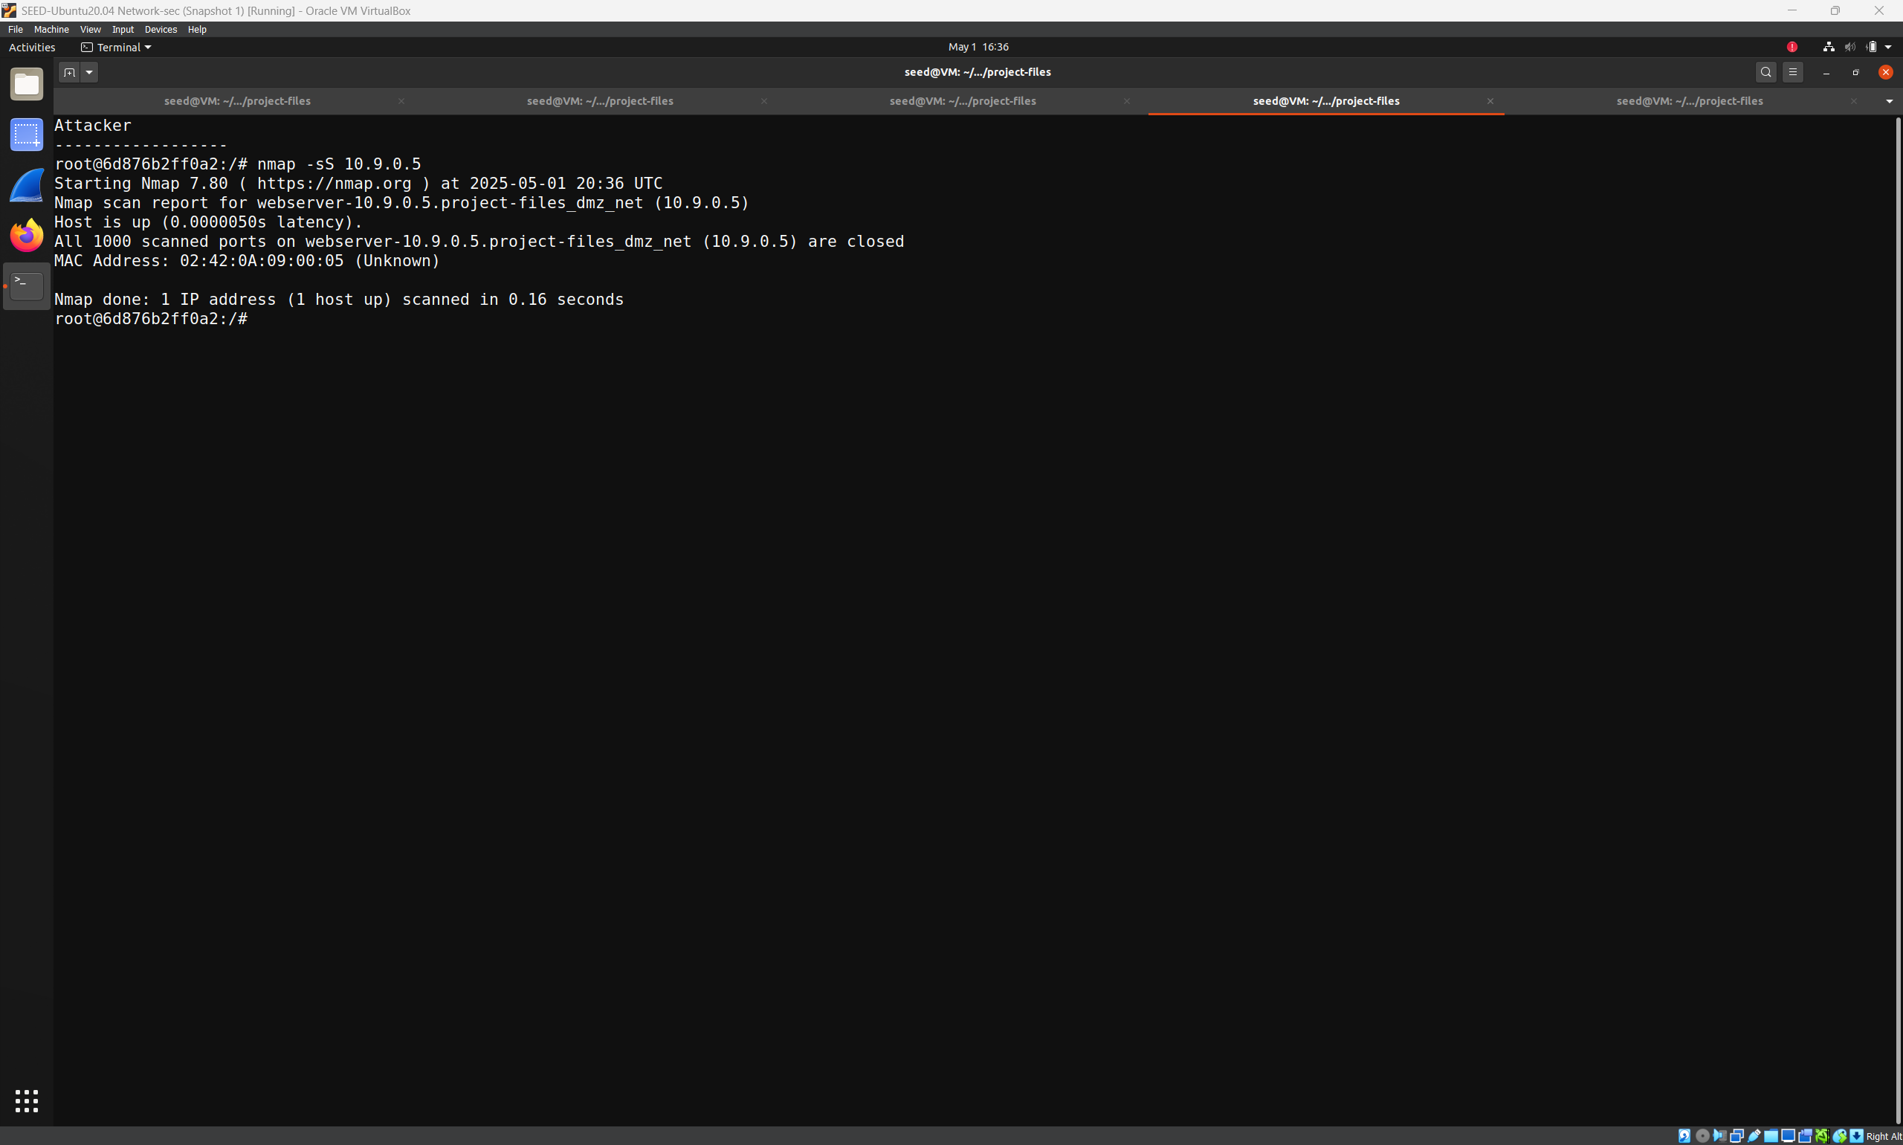
In each case, Snort triggered alerts in real time, displaying the custom messages I had configured for those rules. These alerts appeared in the console and matched the types of attacks I was simulating. I saved screenshots of the alert output to include in the report.
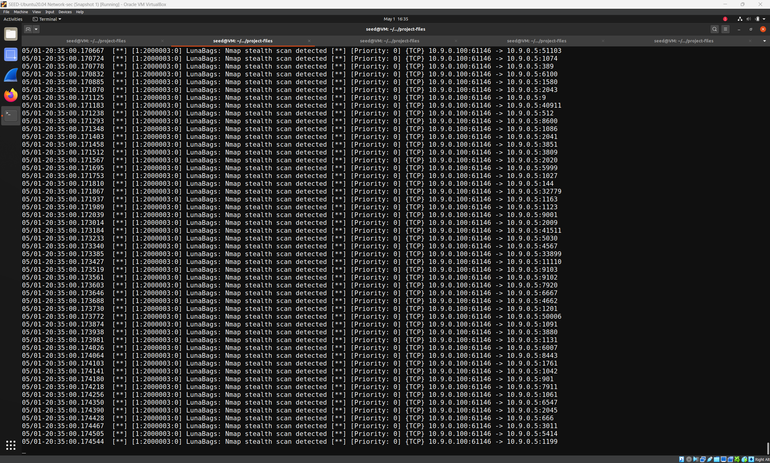
All these tests confirmed that the defenses I set up were working. HTTPS provided encryption, the firewall blocked or allowed traffic based on policy, and Snort detected suspicious activity as planned. Together, these layers created a strong and visible security posture for Luna Bags’ network.
Recommendations
This setup was chosen because it makes sense for where Luna Bags is today. The company needs to protect a public website, manage internal systems, and support both on site and remote workers. HTTPS protects user data. The firewall controls access. Snort keeps watch in the background.
Looking ahead, I recommend switching to a certificate from a trusted provider. That will eliminate the browser warnings and give users more confidence in the site. The firewall should be reviewed regularly to make sure it still meets the company’s needs. And Snort should be kept up to date, with alerts connected to a system that makes it easy to monitor. These changes will help keep the network strong and ready to face new threats.
Project Reflection
When I designed this project, I worked under the assumption that outside attacks were the most likely threat and that traffic would be visible from the router. These assumptions made it possible to keep the setup simple while still covering the important areas.
This project gave me a chance to apply real world security tools in a hands on way. Setting up HTTPS and writing firewall rules went smoothly. Getting Snort to trigger the right alerts took more time, but it taught me how to test and tune detection rules. Seeing everything that come together was satisfying and reinforced how important it is to build layered defenses and actually test them. It was a great learning experience overall.

Conclusion
This project gave me the opportunity to build and test a complete network defense strategy for a small but growing company like Luna Bags. By combining HTTPS encryption, firewall access control, and intrusion detection with Snort, I was able to create a multi-layered defense that protects both public-facing services and internal systems. Each part of the setup was tested and was shown to work, and together they formed a stronger overall security posture than any one tool could provide on its own.
Working on this project has helped us understand how different security tools can be used together in a real-world environment. I also learned the importance of testing, tuning, and documenting each part of the setup. Most importantly, I saw how even a simple network can benefit from clear security boundaries and visibility. This experience gave me practical skills and confidence that I’ll take with me into future cybersecurity roles.
Appendix
Commands and technical setups
A.1 HTTPS Configuration on Apache Web Server
Commands run inside the webserver container (10.9.0.5):
apt update -y
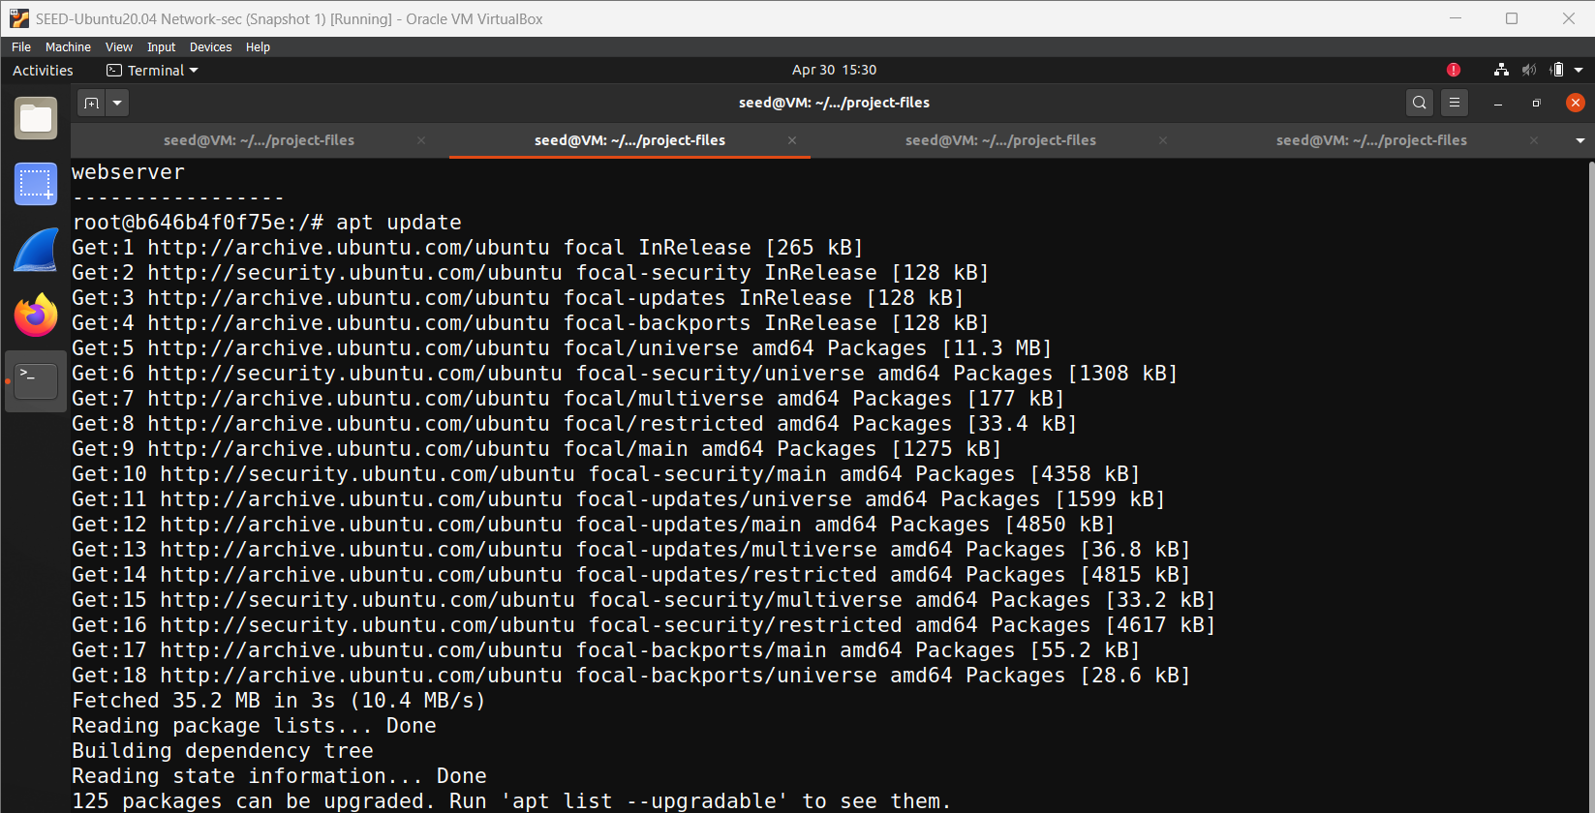
apt install apache2 openssl -y
mkdir -p /etc/apache2/ssl
openssl req -x509 -nodes -days 365 -newkey rsa:2048 \
-keyout /etc/apache2/ssl/apache.key \
-out /etc/apache2/ssl/apache.crt \
-subj "/C=US/ST=NY/L=NewYork/O=LunaBags/CN=10.9.0.5"
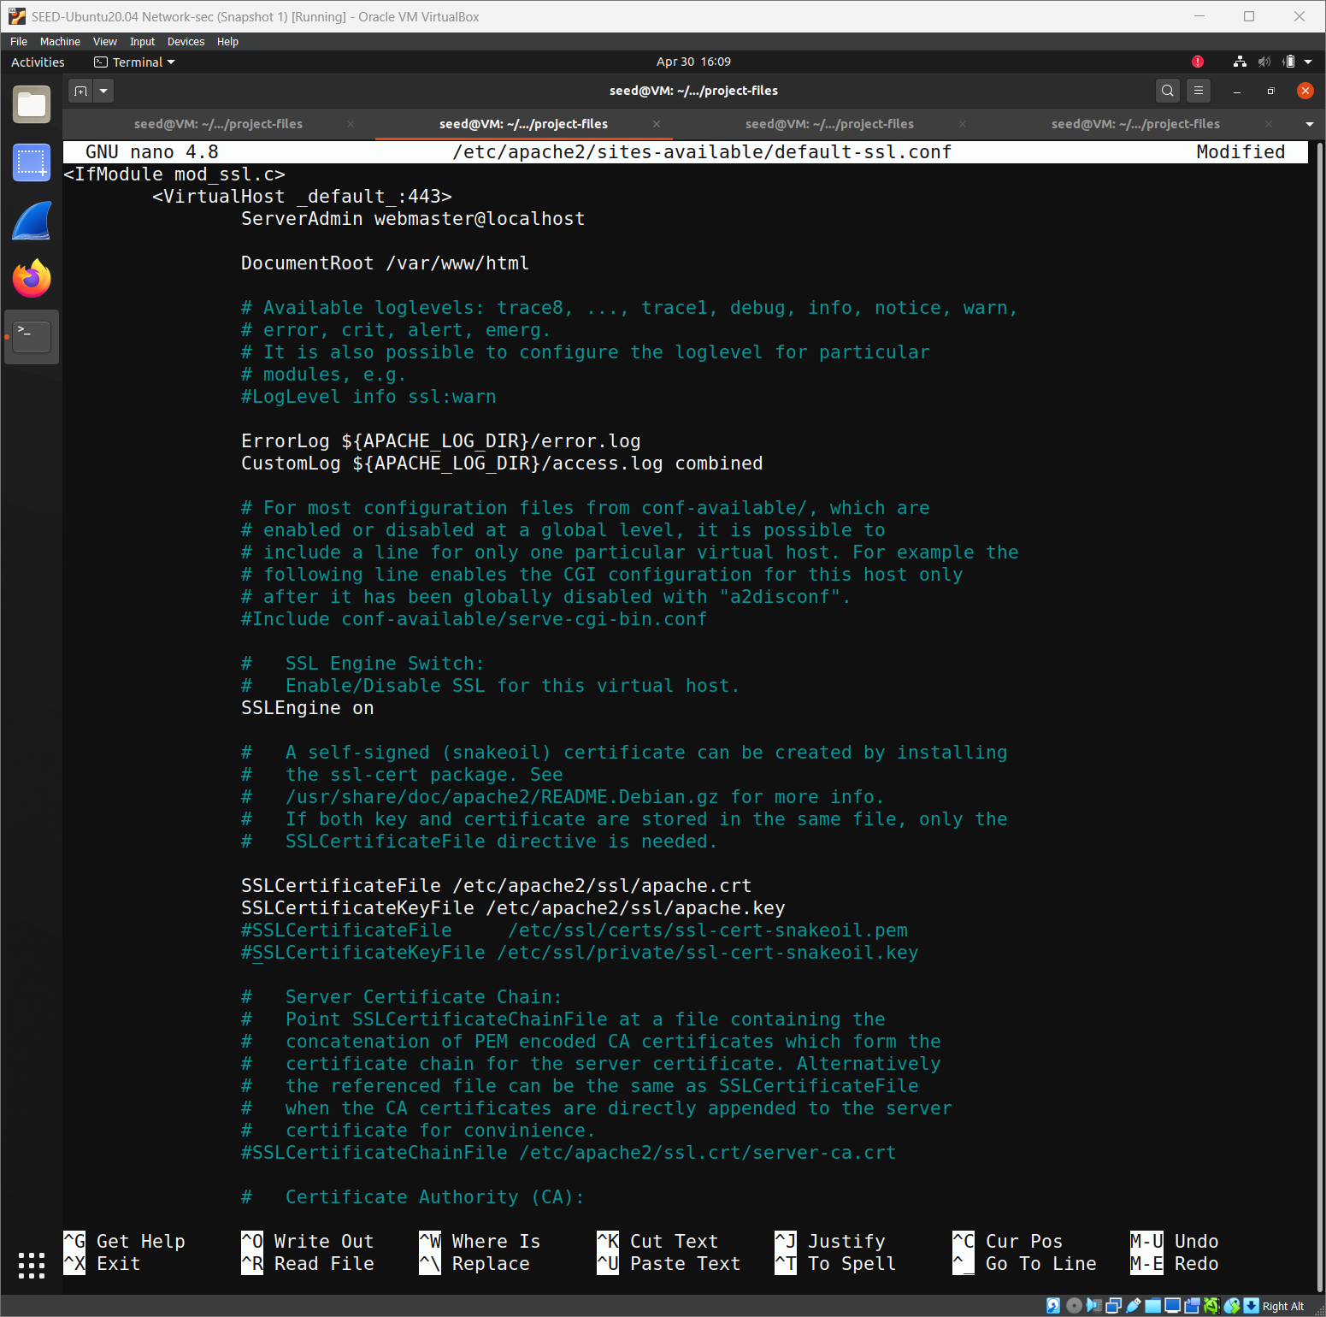
a2enmod ssl
a2ensite default-ssl

# Edit the following file:
nano /etc/apache2/sites-available/default-ssl.conf
(Set SSLCertificateFile and SSLCertificateKeyFile accordingly)
service apache2 restart
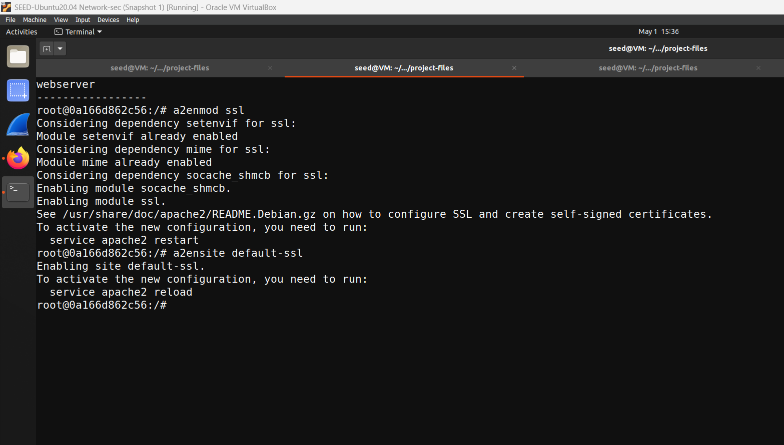
Test command from a different host machine:
curl -k https://10.9.0.5
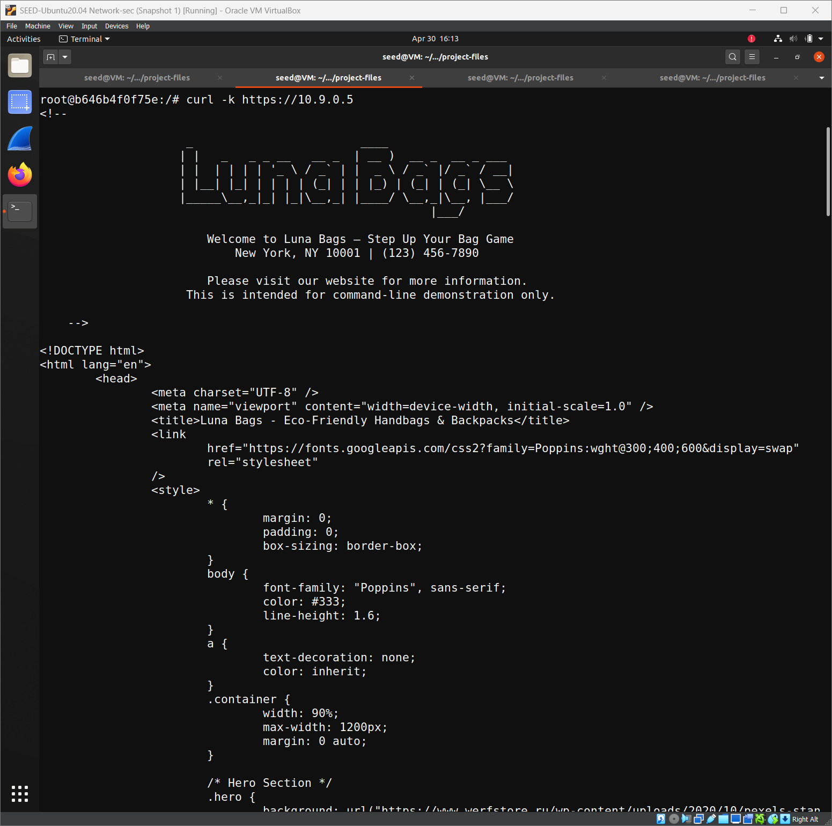

A.2 Firewall Rules on the Router (10.9.0.2)
Commands run to set up iptables:
iptables -F
iptables -X
iptables -t nat -F
iptables -P FORWARD DROP
iptables -A FORWARD -p tcp -d 10.9.0.5 --dport 80 -j ACCEPT
iptables -A FORWARD -p tcp -d 10.9.0.5 --dport 443 -j ACCEPT
iptables -A FORWARD -s 192.168.60.0/24 -d 192.168.60.0/24 -j ACCEPT
iptables -A FORWARD -m state --state ESTABLISHED,RELATED -j ACCEPT
iptables -A FORWARD -p icmp -m limit --limit 1/s --limit-burst 5 -j ACCEPT
iptables -t nat -A POSTROUTING -s 10.9.0.0/24 -o eth0 -j MASQUERADE
iptables -L -v
A.3 Snort Setup and Custom Rules
Install and run Snort:
apt update -y
apt install snort -y
Edit /etc/snort/snort.conf
ipvar HOME_NET [10.9.0.0/24,192.168.60.0/24]
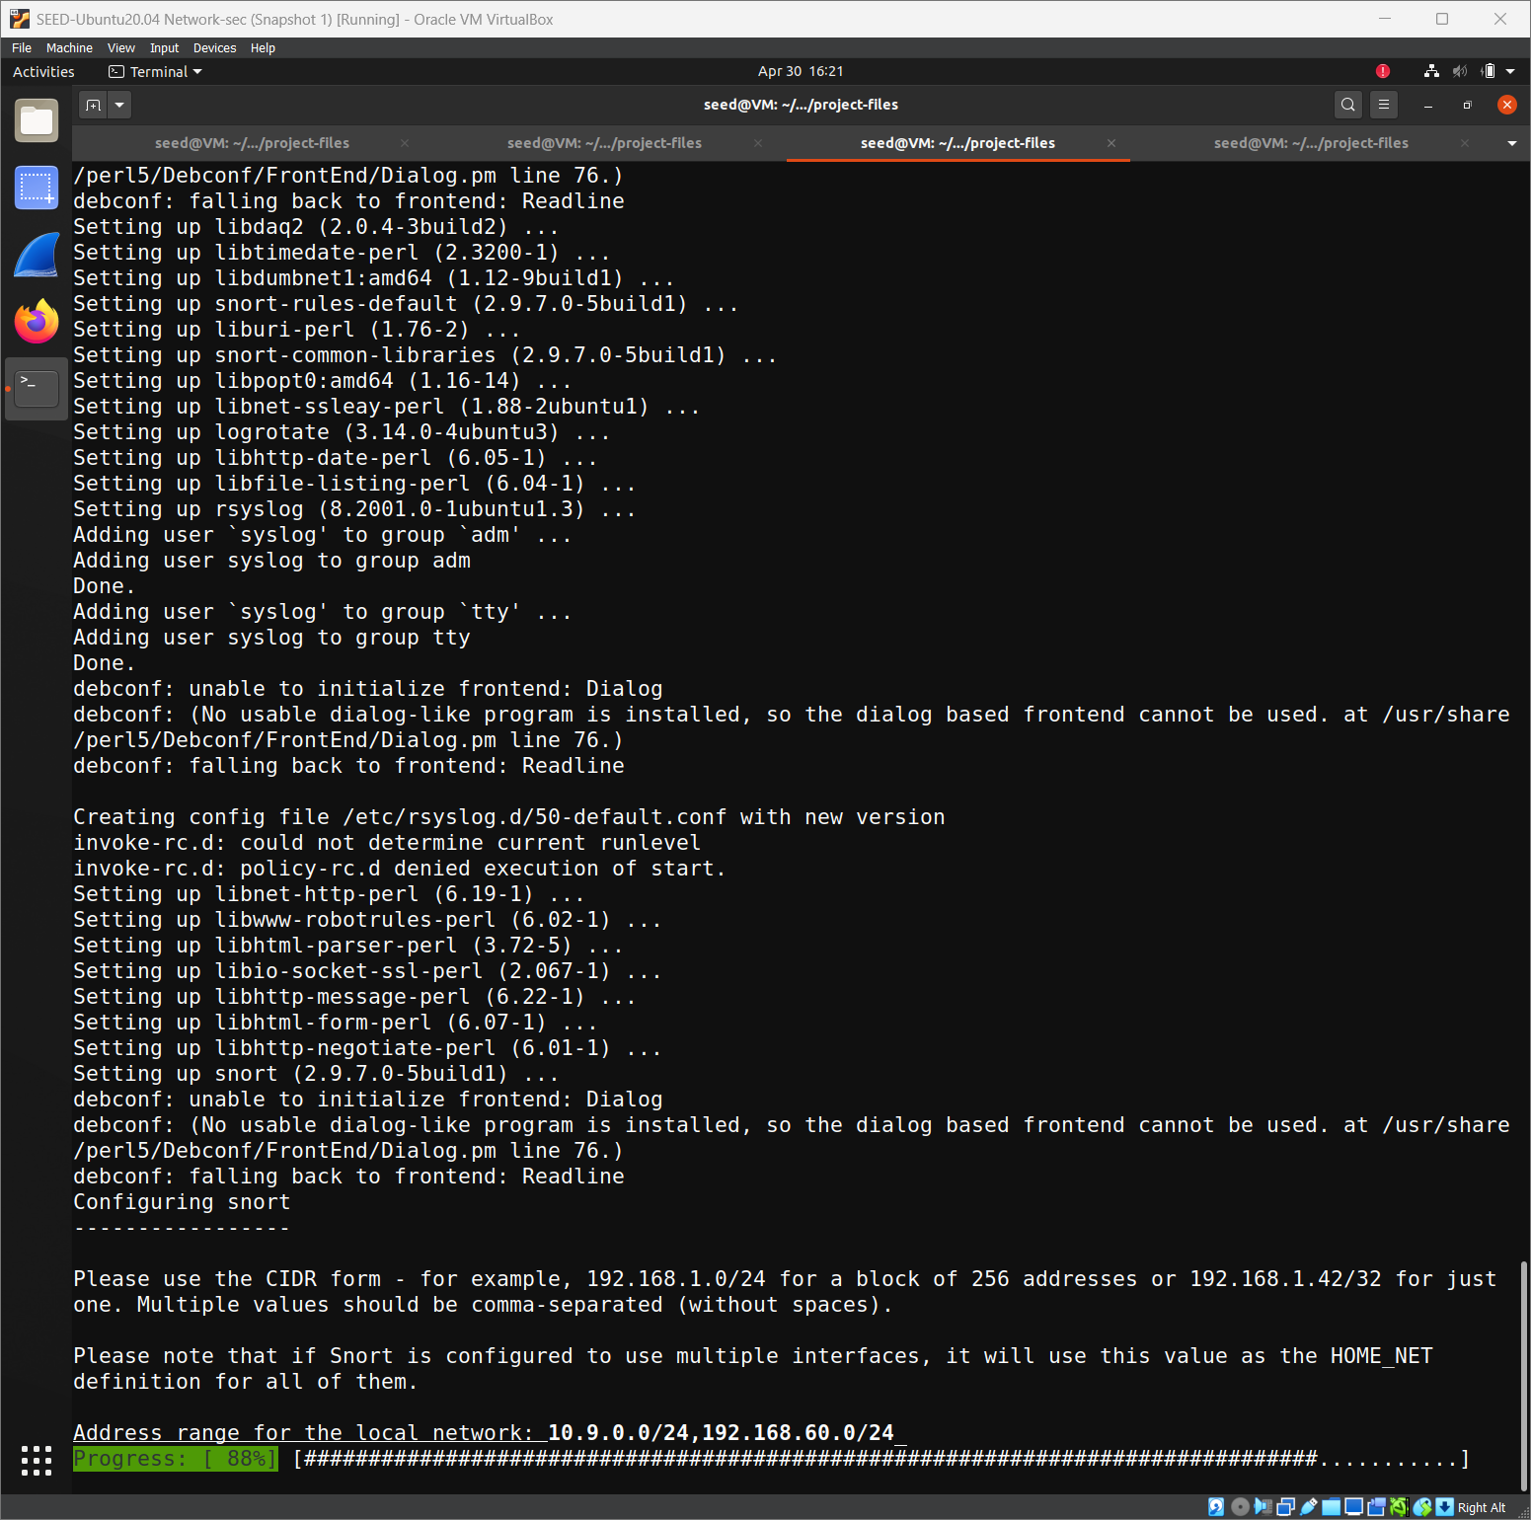
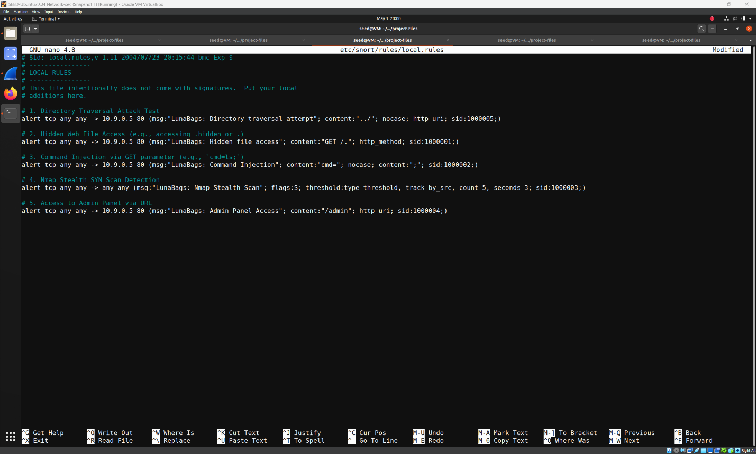
Create /etc/snort/rules/local.rules:
alert tcp any any -> 10.9.0.5 80 (msg:"LunaBags: Hidden file access"; content:"GET /."; http_method; sid:1000001;)
alert tcp any any -> 10.9.0.5 80 (msg:"LunaBags: Command Injection"; content:"cmd="; nocase; content:";"; sid:1000002;)
alert tcp any any -> any any (msg:"LunaBags: Nmap Stealth Scan"; flags:S; threshold:type threshold, track by_src, count 5, seconds 3; sid:1000003;)
alert tcp any any -> 10.9.0.5 80 (msg:"LunaBags: Admin Panel Access"; content:"/admin"; http_uri; sid:1000004;)
Run Snort with console output:
snort -A console -q -c /etc/snort/snort.conf -i eth0
A.4 Attack Simulation Commands
Nmap stealth scan:
nmap -sS 10.9.0.5



